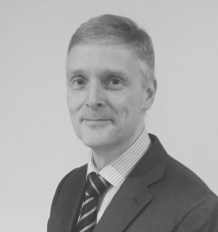
Paul has worked in the life science sector for over 20 years. During this time he has worked as a corporate financier, advising companies on fundraising and partnering; as a venture capitalist leading investments in a variety of early stage companies in Europe and the US; and as the director of a start-up company.
Paul is currently Head of Strategy at BTG plc, a role that encompasses Business Development (including Mergers and Acquisitions and Strategic Investments) as well as Digital Health. BTG plc is a FTSE 250 company that develops, manufactures and sells therapies in specialist areas of medicine such as oncology, pulmonology and vascular disease (www.btgplc.com). BTG has been an active acquirer of innovative companies, having purchased six companies since 2008.
Paul has a degree and doctorate (in Cell Biology) from the University of Oxford. He is also a chartered accountant and spent his early business career specialising in corporate recovery and turnaround consulting at Arthur Andersen.
Paul lives with his family in the Oxford area and when not running, cycling or being a touchline Dad, is a keen cartoonist and birdwatcher.

